The Raleigh Engineers Club
P.O. Box 1268 • Raleigh/NC • 27602
Phone: 546-5690
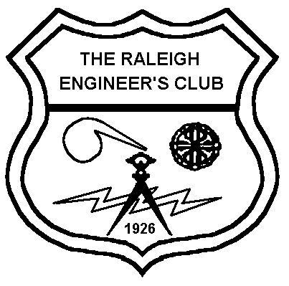

February 11, 2026

To: Wake County HS Seniors Accepted into NC State University’s College of Engineering

From: George Sharpe, REC President and Chairman of the Scholarship Committee

Re: 2026 Raleigh Engineers Club Scholarship

The Raleigh Engineers Club is now accepting applications for the 2026 Raleigh Engineers Club Scholarship. The Raleigh Engineers Club (REC) has been in existence since 1926. The Club promotes engineering as a profession through monthly technical meetings (earning PDHs) and supports those pursuing a future in an engineering discipline. Our members have diverse backgrounds in engineering and represent many organizations located in the greater Raleigh area.

The greatest impact REC offers annually is to provide one scholarship during the spring of each year to a Wake County HS Senior who has been accepted into the College of Engineering at NC State University with plans to attend the fall semester of that year. The scholarship’s value is one semester of tuition at the in-state rate, plus the engineering school’s Program Enhancement Fee, totaling over $4.000.00. Money to fund the scholarship is provided by member donations, member employer matching grants and a grant from the NC Society of Engineers.

The winner will be selected from those applying, consisting of students from any Wake County high school, who meet the scholarship criteria and submit a complete application.

A complete application consists of:

- The REC Scholarship Questionnaire
- A pdf scan of your NCSU - College of Engineering Acceptance Letter
- A pdf scan of your most current high school transcript
- A Letter of Recommendation from a faculty member familiar with you*

Send the Questionnaire (Word or PDF) and one scan (PDF) of the Acceptance Letter and Transcript, together, all in ONE EMAIL, to the following address: GeorgeSharpeJr@gmail.com .

*The Letter of Recommendation should be sent as an attachment and emailed separately by the faculty member to the same email address used for the application.

Both emails must be sent, and a complete application must arrive, no later than 5:00 pm on Friday, April 17, 2026 -- NO EXCEPTIONS! No confirmation of delivery will be sent; however, you are welcome to follow up by email to ensure all information arrived and your application is complete, well before the deadline.

